Departamento de Informática – UTFSM

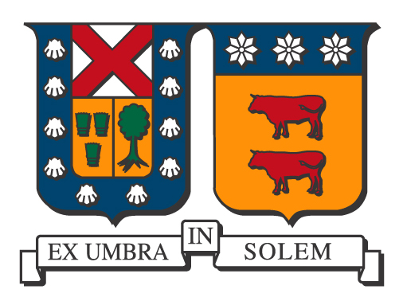
Ciclo de Coloquios 2018

El Departamento de Informática de la Universidad Técnica Federico Santa María tiene el agrado de invitar a la comunidad Universitaria a su ciclo de coloquios. Esta presentación se realizará en el Auditorio Claudio Matamoros (F-106), en la Casa Central el día Martes 24 de abril las 11:45 y por videoconferencia a la Sala de Reuniones, Departamento de Informática, Campus San Joaquín, UTFSM.

Título

Herding Cats; or How to Build an Interdisciplinary Data Science Program

Expositor

Cecilia Aragon
Professor, Human-Centered Design & Engineering, University of Washington, USA

Mini Bio
Cecilia Aragon is Director of the Human Centered Data Science Lab, Founding Co-Director of the University of Washington Data Science Master’s Program, Professor in the Department of Human Centered Design & Engineering and Senior Data Science Fellow at the eScience Institute at the University of Washington in Seattle, WA, USA. She earned her Ph.D. in Computer Science from UC Berkeley in 2004, and her B.S. in mathematics from the California Institute of Technology. Her research focuses on human-centered data science, an emerging field at the intersection of human-computer interaction (HCI), computer-supported cooperative work (CSCW), and the statistical and computational techniques of data science. She has authored or co-authored over 100 peer-reviewed publications and over 130 other publications in the areas of HCI, CSCW, data science, visual analytics, machine learning, and astrophysics. In 2008, she received the Presidential Early Career Award for Scientists and Engineers (PECASE), the highest honor bestowed by the US government on outstanding scientists in the early stages of their careers, for her work in collaborative data-intensive science. Aragon's research has been recognized with over US$27M in grants from federal agencies, private foundations, and industry, and has garnered six Best Paper awards since 2004. She was awarded a 2017-18 Fulbright Fellowship to conduct research in human-centered data science and teach visual analytics in Chile.

Resumen
Extraordinary advances in our ability to acquire and generate data in just about every field of science, humanities, education, and business are transforming the fundamental nature of discovery across domains. "Data scientist" is the fastest growing job title in the world today.
Five years ago, when the University of Washington in Seattle decided to create a data science master’s degree to keep up with demand for training in this new field, six departments laid claim to relevant expertise. We might have ended up with six competing programs; instead, we worked together to create the largest interdisciplinary master’s program in the history of our university. We’ve been operating for three years, and this year, we received 750 applicants for 45 slots. In this talk, one of the founding directors of the program will discuss ongoing initiatives at the University of Washington, the process of getting six departments to work together, how the data science curriculum and goals were developed, and finally, will speculate upon future directions for data science.

Lugar y Fecha
24 de abril de 2018, 11:45 hrs
Sala de Reuniones, Auditorio Claudio Matamoros (F-106), Casa Central, UTFSM.
La charla se transmitirá́ en videoconferencia a la sala de reuniones, Departamento de Informática, UTFSM, Campus San Joaquín.

